TI DSP, MCU 및 Xilinx Zynq FPGA
프로그래밍 전문가 과정

강사 – lnnova Lee(이상훈)
gcccompil3r@gmail.com
학생 – 하성용
accept0108@naver.com

68일차
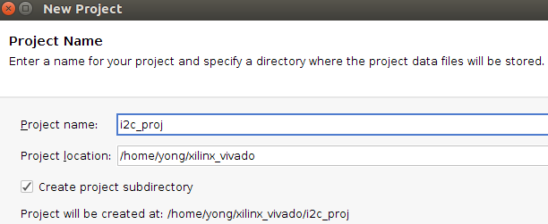
//
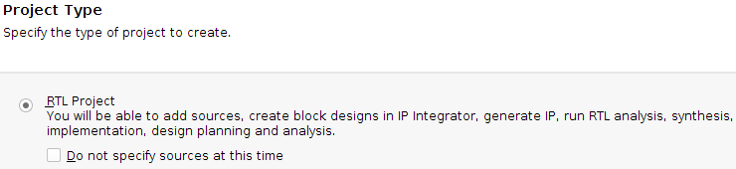
//
//
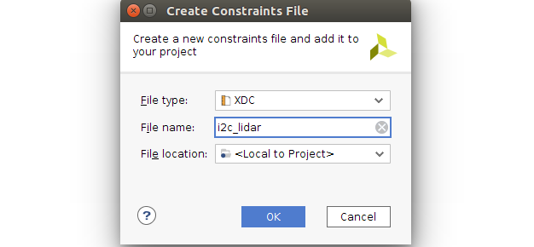
//
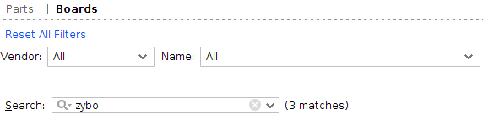
//

//

//

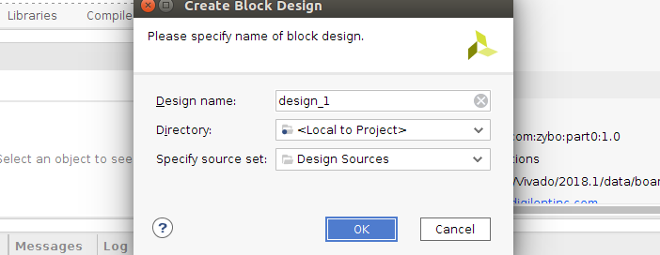
//
//

//ZYNQ 더블클릭 → MIO Configuration 설정
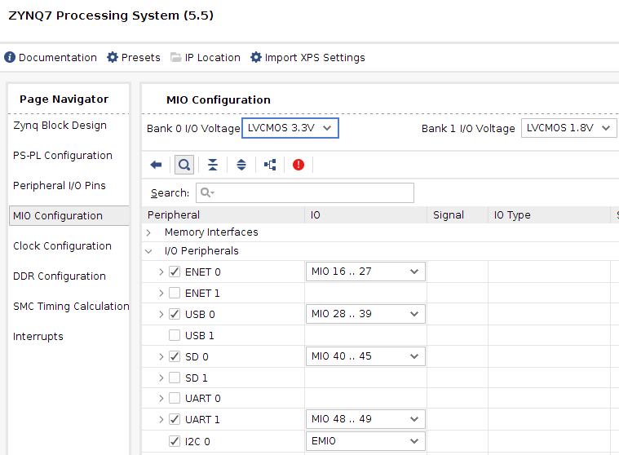
//
ZYNQ 생긴 IIC_0 우클릭 create interface port
//
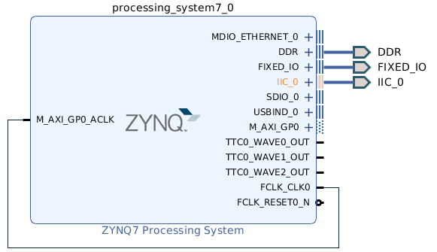
//
소스에 wrapper

Run Synthesis
다하고
//
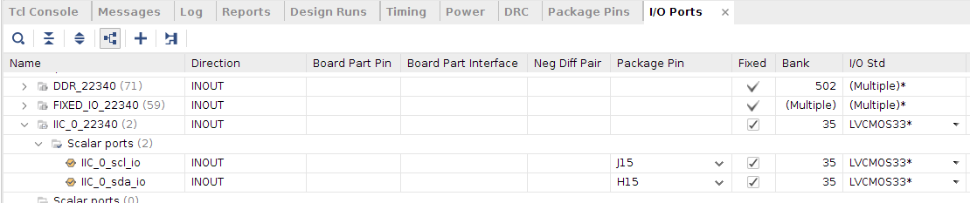
//
제너레이트 비트스트림

//
비트스트림 다만들엇으면 익스포트 하드웨어 (인클루드 체크)

petalinux-config --get-hw-description=~/xilinx_vivado/project_1/project_1.sdk
//save → yes → exit
petalinux-config -c u-boot

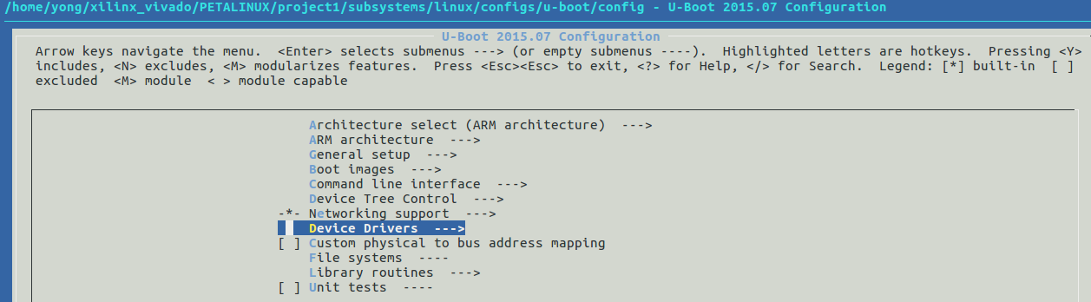
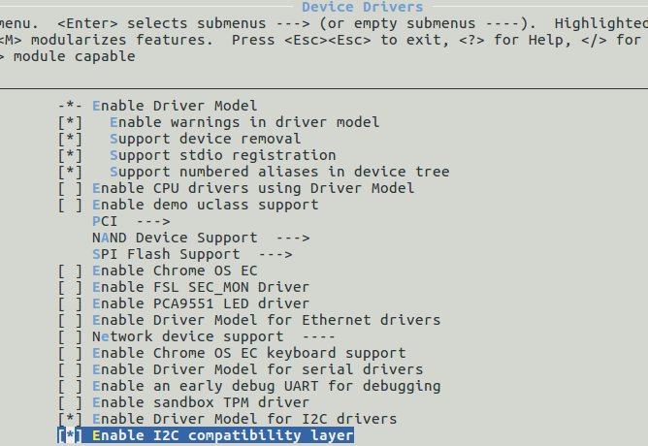

//petalinux-create -t apps -n project1 –enable

//cd components/apps/project1/

i2c_libar.c → 해당 소스명으로 여기선 project1.c
vi project1.c

#include <stdio.h>
#include <linux/i2c.h>
#include <linux/i2c-dev.h>
#include <sys/ioctl.h>
#include <fcntl.h>
#include <unistd.h>
#include <errno.h>
#include <string.h>
#include <stdlib.h>
#include <sys/types.h>
#include <sys/stat.h>

#define I2C_FILE_NAME_0 "/dev/i2c-0"
#define I2C_FILE_NAME_1 "/dev/i2c-1"
#define LIDAR_SLAVE_ADDR 0x62

#define ACQ_COMMAND 0x00
#define STATUS 0x01
#define SIG_COUNT_VAL 0x02
#define ACQ_CONFIG_REG 0x04
#define THRESHOLD_BYPASS 0x1C
#define RAED_FROM

#define NO_CORRECTION 0
#define CORRECTION 1

#define AR_VELOCITY 0
#define AR_PEAK_CORR 1
#define AR_NOISE_PEAK 2
#define AR_SIGNAL_STRENGTH 3
#define AR_FULL_DELAY_HIGH 4
#define AR_FULL_DELAY_LOW 5

#define OUTPUT_OF_ALL 0
#define DISTANCE_ONLY 1
#define DISTANCE_WITH_VELO 2
#define VELOCITY_ONLY 3

#define USAGE "i2c_LiDAR_fn <OUTPUT_OPTIONS> <I2C_DEVIVE_NUMBER>\n"\
"<OUTPUT_OPTIONS>\n"\
"0 : output of all\n" \
"1 : distance only\n"\
"2 : distance with velocity\n"\
"3 : velocity only\n"

unsigned get_status();
void i_read(unsigned char, unsigned, unsigned char*);
void i_write(unsigned char reg, unsigned char value);
void measurement(unsigned char, unsigned char, unsigned char*);
void display(unsigned char, unsigned char*);

int fd = 0;

int main(int argc, char *argv[]) {
unsigned char receives[8] = {AR_VELOCITY, 0, 0, AR_PEAK_CORR, AR_NOISE_PEAK
, AR_SIGNAL_STRENGTH, AR_FULL_DELAY_HIGH, AR_FULL_DELAY_LOW};
unsigned char i, options;
char *file_name = NULL;

if(argc < 2) printf("%s\n", USAGE);
else if(argc > 2 && atoi(argv[2])) file_name = I2C_FILE_NAME_1;
else file_name = I2C_FILE_NAME_0;

options = atoi(argv[1]);

if((fd = open(file_name, O_RDWR)) < 0) {
perror("---OPEN DEVICE ERROR");
return -1;
}

if(ioctl(fd, I2C_SLAVE, LIDAR_SLAVE_ADDR) < 0 ) {
perror("---SLAVE ADDR CONNECT ERROR ");
return -1;
}

i_write(SIG_COUNT_VALM 0x80);
i_write(ACQ_CONFIG_REG 0x08);
i_write(THRESHOLD_BYPASS 0x00);

while(1) {
measurement(CORRECTION, options, receives);
for(i=0; i<99; i++) measurement(NO_CORRECTION, options, receives);
//power state control
//close
// if() close(fd);
}

close(fd);

return 0;
}

unsigned get_status() {
unsigned char buf[1] = {STATUS};

if(write(fd, buf, 1) !=1) {
perror("---WRITE REGISTER ERROR ");
return -1;
}

if(read(fd, buf, 1) !=1 ) {
perror("---WRITE REGISTER ERROR ");
return -1;
}

return buf[0] & 0x01;
}

void i_read(unsigned char reg, unsigned read_size, unsigned char *receives) {
unsigned char buf[1] = {reg};
unsigned busy_flag = 1, busy_counter = 0;

while(busy_flag) {
busy_flag = get_status();
busy_counter ++;
if(busy_counter > 9999) {
printf("BUSY COUNT TIME OUT !\n");
return ;
}
}
if(!busy_flag) {
if(write(fd, buf, 1) !=1) {
perror("---WRITE REGISTER ERROR");
return -1;
}

if(read(fd, receives, read_size) != read_size) {
perror("---WRITE REGISTER ERROR ");
return -1;
}
}
}

void i_write(unsigned char reg, unsigned char value) {
unsigned char buf[2] = (reg, value);

if(write(fd, buf, 2) != 2) {
perror("---WRITE REGISTER ERROR");
return -1;
}
usleep(1000);
}

void measurement(unsigned char is_correction, unsigned char options, unsigned char *buf)
{
unsigned char i;
if(is_correction) i_write(ACQ_COMMAND, 0x04);
else i_write(ACQ_COMMAND, 0x03);
i_read(READ_FROM, 8, buf);

for(i=1; i<6; i++) buf[i] = buf[i+2];

display(options, buf);
}

void display(unsigned char options, unsigned char *buf) {
unsigned char i;
char* strings[5] = {"Velocity", "Peak value in correlation record"
"Correlation record noise floor", "Received signal strength", "Distance"};
buf[AR_FULL_DELAY_HIGH] = buf[AR_FULL_DELAY_HIGH] << 8 | buf[AR_FULL_DELAY_LOW];

/*
AR_VELOCITY 0
AR_PEAK_CORR 1
AR_NOISE_PEAK 2
AR_SIGNAL_STRENGTH 3
AR_FULL_DELAY_HIGH 4
AR_FULL_DELAY_LOW 5
*/

switch(options) {
case OUTPUT_OF_ALL :
for(i=0; i<5; i++) printf("%s \t\t\t\t = %d\n", strings[i], buf[i]);
break;
case DISTANCE_ONLY :
printf("%s \t\t\t\t = %d\n", strings[4], buf[AR_FULL_DELAY_HIGH]);
break;
case DISTANCE_WITH_VELO :
printf("%s \t\t\t\t = %d\n", strings[0], buf[AR_VELOCITY]);
printf("%s \t\t\t\t = %d\n", strings[4], buf[AR_FULL_DELAY_HIGH]);
break;
case VELOCITY_ONLY :
printf("%s \t\t\t\t = %d\n", strings[0], buf[AR_VELOCITY]);
break;
}
printf("\n");
}

//:wq로 저장하고 나옴

